**Report on the Independent Peer Review of**

**Gulf of Alaska Demersal Shelf Rockfish Assessment**

Prepared for:

The Center for Independent Experts

Dr Kevin Stokes

Stokes.net.nz Ltd

E-mail: kevin@stokes.net.nz

**EXECUTIVE SUMMARY**

*The report must be prefaced with an Executive Summary providing a concise summary of the findings and recommendations and specify whether the science reviewed is the best scientific information available.*

The review of Gulf of Alaska (GoA) Demersal Shelf Rockfish (DSR) Assessment is focused on new methods (a random effects model (REMA) and a surplus production model (SPM)) for assessing yelloweye rockfish, with consideration of the potential development of an alternative management Tier if an SPM is used. The ToR are somewhat unusual for a CIE review and do not naturally lead to specifying whether the science reviewed is the best scientific information available. Rather, the ToR relate to development considerations.

Yelloweye rockfish is part of the GoA DSR rockfish assemblage. Yelloweye overfishing limit (OFL) and allowable biological catch (ABC) are set using Tier 5 of the North Pacific Fishery Management Council (NPFMC) Fishery Management Plan (FMP) while the other species OFL are set using Tier 6. All OFL and ABC are summed for the DSR.

Until 2022, OFL and ABC were set using Tier 5 of the NPFMC Tier system, with biomass estimates derived from submersible/ROV surveys and an estimate of M. In 2022, the OFL was set using biomass estimates from a new REMA approach. An in-development SPM was also considered. The focus of the review is on the new methods (REMA and an SPM) for assessing yelloweye rockfish, and on data needed to implement these.

If Tier 5 management is used, then biomass estimates are required and need to be as accurate and timely as feasible. The ROV-based estimates are always a combination across areas sampled on a 4-year rolling basis and are always therefore lacking in recency. Using CPUE from the International Pacific Halibut Commission (IPHC) FIS and the new REMA approach is a valid way of estimating as best possible the most recent biomass to be used in OFL setting. Use of an SPM adds little to the estimation of recent biomass but may in principle ensure consistency of an Fmsy estimate with the estimated biomass. However, there will be uncertainty in any such estimate, and it is not immediately obvious that there will be a benefit compared to the current approach using an estimate of M. The estimate of M currently used is not well justified, and it seems to be low compared to many derived estimates. Updating and improving the estimate of M is overdue and should be done.

For yelloweye rockfish, comprising greater than 90% of the DSR catch, there is a reliable estimate of biomass as required at Tier 5 and an estimate of M is used to determine FOFL, as required in the FMP. The Tier 5 approach is well tried and tested and the 0.75 multiplier to calculate FABC accounts for M being theoretically greater than FMSY. For other DSR species there is only catch information. Setting FOFL and FABC by species and summing them seems reasonable, as long as the distribution and relative frequency of landings remains constant for all DSR species. The use of the maximum catch by species from 2010-2014 is justified as being for the only years available. It is not obvious how this relates to the Tier 6 requirements for basing the OFL calculation on an average catch for a given period “*unless an alternative value is established by the SSC on the basis of the best available scientific information*”. No reference is made to an SSC decision on this.

Overall, the yelloweye bycatch estimation approach necessary for catch history determination and use in the SPM is probably sufficiently right to use alongside other uncertain sources of removals in exploring SPM development, so long as uncertainties are recognized and investigated. The credibility of estimated bycatch reduces substantially prior to 1980. The use of inflated CVs and risk analysis is a practical way to do this. An explanation would be helpful about why landed yelloweye weights are used instead of survey weights and how this might affect estimates. Presumably, mean landed weights are greater than mean survey weights (as smaller fish are more likely to be discarded).

If an SPM is to be developed for yelloweye, then it is more pressing in the short term to develop a model that is regarded as sufficient to capture the dynamics of the yelloweye stock in a way that is suitable to inform management. The question of then using the SPM in decision-making is moot. Without MSE to test efficacy of SPM within the Tier system more generally, it is hard to see how an SPM just for yelloweye would in any case be used. The model presented in 2022 is a complete model, fitting everything all at once and with multiple uncertainties. One way forward would be to use a “yelloweye-like” simulated data set to test stepwise development of data inclusion to validate a final SPM approach which can then be applied to the real yelloweye data. This would not be a comparison of the SPM with typically used age-structured methods, but it would allow SPM development with a known basis.

**BACKGROUND**

*The main body of the reviewer report shall consist of a* ***Background****, Description of the Individual Reviewer’s Role in the Review Activities, Summary of Findings for each TOR in which the weaknesses and strengths are described, and Conclusions and Recommendations in accordance with the TOR.*

Working from a range of sources (Fishbase; *Cox et al*, 2020; Gertseva and Cope, 2017, 2018; Joy *et al*, 2022), yelloweye rockfish (*Sebastes ruberrimus*) is a long-lived, shallow to middle depth reef-associated bottom dwelling fish. It is distributed from Baja California along the USA and Canadian west coasts and the Gulf of Alaska (GoA). Stocks are recognized as genetically distinct and are managed and assessed by the USA Pacific Fishery Management Council, Canadian DFO, and USA North Pacific Fishery Management Council. While long-lived (circa 115 years but maximum observed 147 years), yelloweye rockfish appears to be relatively early maturing with age at 50% maturity as young as 10 years-old, inferred from Gertseva and Cope (2017, Figs. 55 and 59) or 17 years-old in the GoA (Green *et al*, 2015).

Stock assessments have been conducted by the USA NWFSC (age-structured, using SS3) and Canadian DFO with rebuilding plans developed in Canada (e.g., see Cox et al, 2020). Problems with age-structured modeling for the USA west coast stock (Gertseva and Cope, 2017, 2018) include uncertainties about natural mortality and stock-recruitment steepness, ageing error, and catch history reconstructions given the long history of targeted and indirect commercial fishing and in some case recreational fishing. Nevertheless, age-structured models have formed the basis of management advice for many years in the PFMC area. An age-structured model for yelloweye rockfish for three of the NPFMC management areas (CSEO, EYKT, SSEO; see graphic below) was developed by Green *et al* (2015), implemented in ADMB. Though promising, age-structured modeling was not pursued in favour of management based on continued use of direct estimates of biomass from submersible/ROV surveys. In 2022, a random effects model (REMA; Sullivan et al, 2022) using direct estimates of biomass and IPHC long line survey derived CPUE was used to estimate biomass and as a basis for management advice.

Overfishing Limits (OFL) for yelloweye rockfish in the GoA have been calculated using Tier 5 of the adopted 2020 FMP for Groundfish in the GoA. Tier 5 OFL-setting requires a reliable estimate of biomass and an estimate of natural mortality, M. No discussion on the current level of M is in the Joy *et al* (2022) paper that formed the basis for management decision-making, nor is there discussion in recent Plan Team/SSC documents. The history of the use of M=0.02 is explained in Green *et al* (2015), from which it appears i) that further work to refine the estimate was underway and ii) 0.02 may be conservative. However, no update on M estimation was reported in Joy *et al* (2022). The OFL for yelloweye rockfish is added to species-specific OFL calculated under Tier 6 for associated demersal shelf rockfish (DSR) for which only catch data are available as a basis for setting the OFL.

Until 2022, biomass estimates for yelloweye rockfish used in the OFL calculation were made using Alaska Department of Fish and Game (ADFG) submersible/ROV surveys. Surveys have taken place on a roughly 4-year rolling cycle across four areas but have been interrupted for a variety of logistic and technical issues. The survey observations along line transects within defined suitable habitat areas (shown in yellow in the graphic below - Fig 14.7 of Joy *et al*, 2022) (Figure 1) have been analysed using well-known hazard probability of detection approaches to estimate absolute biomass in four separate areas. Survey technology and practice has evolved over time, as has the definition of suitable habitat and the methods used to estimate detection probabilities. Methods are described in Green *et al* (2015) and are largely repeated with updates in Joy *et al* (2022).

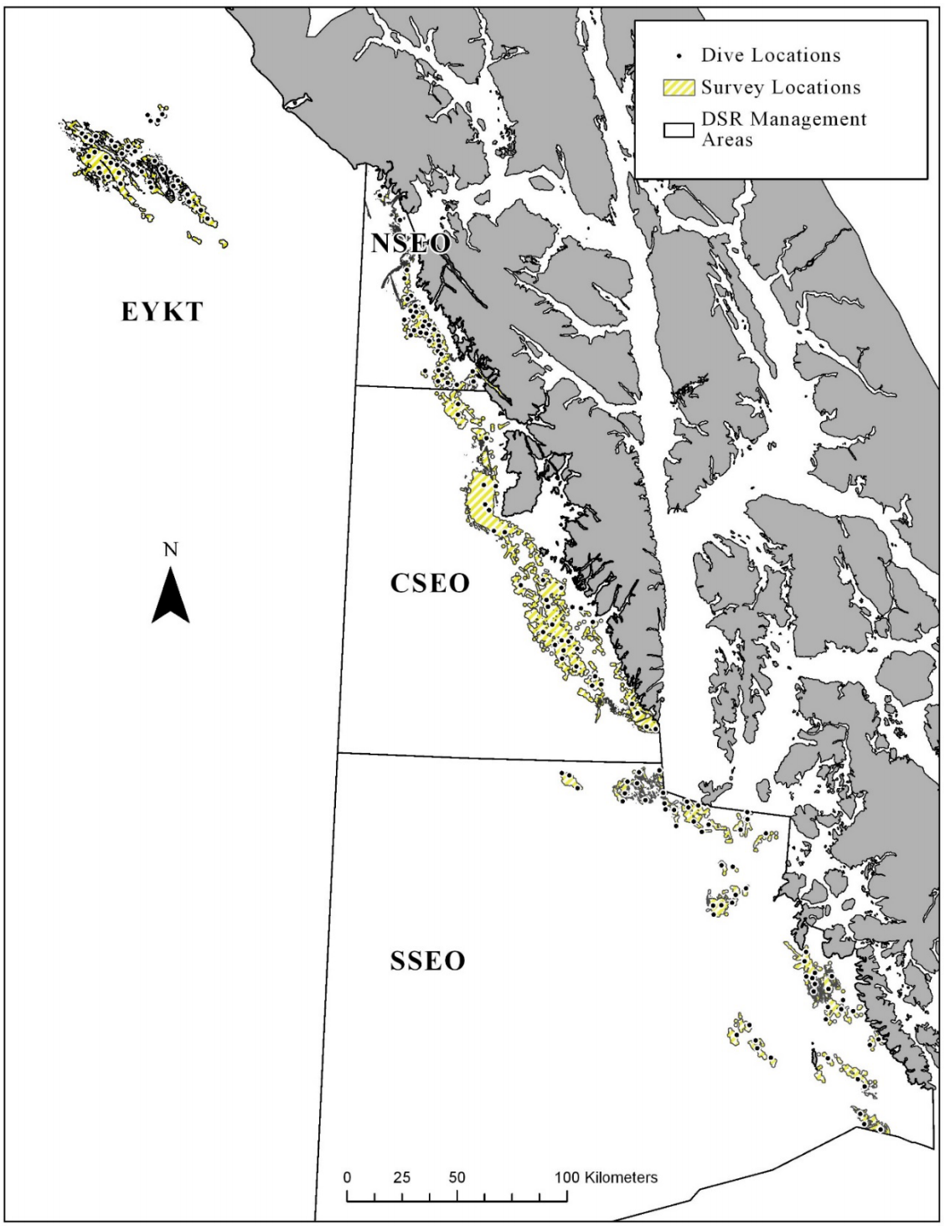

Figure 1: Survey areas

Details of the ROV survey and analysis methods are not explicitly to be reviewed here and the scope statement for the review is to “*review … new methods”*, which I interpret primarily as the SPM for potential future use in management, in place of REMA as adopted in 2022 for management use, including how SPM has been implemented. However, ToR 1 includes a clause (“…and model methods…”) that might be interpreted as meaning all methods feeding into current and prospective management (i.e., also review the ROV methods and IPHC CPUE estimation). However, no explicit mention is made in the ToR of IPHC CPUE estimation, which is also central to REMA and SPM approaches while, in contrast, explicit mention is made of yelloweye rockfish bycatch estimation which is specific to the new method (SPM) under review. Further complicating interpretation of the ToR is that REMA methods have already been reviewed by the CIE in 2023 (see two “*Biomass-based Stock Assessment Approaches Review Report*” at <https://www.st.nmfs.noaa.gov/science-quality-assurance/cie-peer-reviews/cie-review-2023>).

The key background for this review is as outlined under ‘scope” of Appendix 1: *The goal of this review will be to ensure that the stock assessment represents the best available science to date and that any deficiencies are identified and addressed. In 2022, the stock assessment authors introduced new methodologies for assessing a major component species of the DSR complex, yelloweye rockfish. Review of these new methods and their application to the North Pacific Fishery Management Councils (NPFMC) harvest control rules are requested.* The four terms of reference (ToR) for the review are broadly in line with this scope statement, though with a focus on the new SPM method rather than on the REMA adopted in 2022.

**REVIEWER’S ROLE IN THE REVIEW ACTIVITIES**

*The main body of the reviewer report shall consist of a Background,* ***Description of the Individual Reviewer’s Role in the Review Activities****, Summary of Findings for each TOR in which the weaknesses and strengths are described, and Conclusions and Recommendations in accordance with the TOR.*

The role of the reviewer is set out in the CIE Statement of Work, Attachment A, attached here in Appendix 2.

The review included a two-day remote meeting on 12 and 13 September. All materials (see Appendix 1) were provided in advance and a briefing meeting was held by video conference on 23 August. No panel report is required, and all CIE reviewers are tasked with producing independent reviews that deal with the specific ToR shown at Annex 2 of Appendix 2. To that end, I read all supplied papers as well as a range of other materials necessary to complete the review and prepare this report.

The briefing meeting was very valuable and allowed materials to be organized as requested. It led to an efficient, well-chaired main review meeting. References, Github access, and presentation slides were all high quality. So too was the presentation of materials and flow of discussion. While I had read all materials in advance, my fellow reviewers were more familiar with much of the review content and were consequently more forward and active in discussions than me. Nevertheless, I was involved and hopefully gained sufficient insight to conduct an effective review.

The review ToR are atypical for CIE reviews. The task was not to provide a formal view on an established stock assessment to be used in decision-making, nor even was it part of a dedicated research track process. Rather, it includes a set of related ToR that ask for opinions and advice not just on modeling approaches *per se*, but in the context of advising on how different models might be utilized within the existing NPFMC Tier system.

**SUMMARY OF FINDINGS BY ToR**

*The main body of the reviewer report shall consist of a Background, Description of the Individual Reviewer’s Role in the Review Activities,* ***Summary of Findings for each TOR in which the weaknesses and strengths are described****, and Conclusions and Recommendations in accordance with the TOR.*

There are four review-specific ToR. These are highlighted in *purple italics* to distinguish them from the CIE Tor highlighted in *blue italics*.

**ToR 1** *Evaluate the use of the proposed Bayesian state-space surplus production models, and model methods for use in management of the yelloweye rockfish portion of the GOA Demersal shelf rockfish complex. Specifically, determine if results suggest that the NPFMC Tier 5 approach is appropriate. Should biomass estimates from such a model be used in place of the survey average method currently used for most Tier 5 stocks managed by the NPFMC?*

As noted in the background section, the ToR are related to implementation of the SPM for management purposes rather than its inputs (biomass estimates, CPUE, and catch). However, implementation cannot be considered without comment on these inputs, model choice and assumptions to be made, and in the context of model purpose and use. Given adoption of REMA for OFL/ABC determination in 2022, comment on the REMA implementation and model selection is also pertinent.

The history of submersible and ROV surveys, including analytical methods used, are given in Green *et al* (2015). The main presentation for this review rehearsed the history and analyses used, including updated data and results. The survey outputs as estimates of biomass for separate and combined Southeast Outside District (SEO) management areas have been key to setting OFL under the FMP for many years, including in 2022 when the REMA method was adopted. Regardless of other data (index and/or catch), the estimates of absolute biomass, with assumed catchability of 1.0, are the key determinant of the estimate of current biomass used in OFL setting. Whether used directly or within REMA, under Tier 5 management, the biomass estimates are multiplied by an FOFL set equal to natural mortality, M. As noted above, Green *et al* (2015) describe estimates and current application of M=0.02. However, while the usage is described it is not explicitly justified. Clearer justification would be good. Apart from the estimate of M being questionable, the biomass estimates relate only to defined habitable biomass and are in effect a minimum estimate. It is unclear if historic fishing may have taken place beyond the defined habitat.

The lack of clear justification for the use of M=0.02 at Tier 5 for yelloweye rockfish highlights a general issue with the use of M as a surrogate. It is unclear how the biomass being estimated relates to that value of M as a surrogate for FOFL at Tier 5, or to F%SPR and FMSY from age-structured models at Tiers 1-4, or to FMSY as estimated in various SPM which might potentially be used in a modified Tier system. Biomass definitions are also vague. For current REMA usage, biomass is vulnerable biomass for a selection pattern over recent years. It is not explicitly linked in any way to spawning biomass or SPR. Tier 1-4 biomass is effectively vulnerable biomass with a defined linkage to selection pattern through SPR. For a given SPM, production is related directly to vulnerable biomass with no clear underlying relationship to spawning dynamics. This is an issue especially in considering the SPM and how it might fit within the current NPFMC F40 Policy with respect to meeting National Standard 1 under the MSFCMA (MSA §301 98-623).

The technical details of the submersible/ROV surveys are interesting and much thought has been applied to analyses. Changes through time to gear and deployment are considered and changes (improvements) to analyses are transparent. Green *et al* (2015) reasonably attend to standard assumptions for Distance sampling (Buckland *et al*, 1993). Green *et al* (2015) also describe how estimated fish lengths are converted to weight (using directed and bycatch commercial length-to-weight data) and selection of fish by length to include in the biomass estimation. The size selection is based on the minimum observed in the commercial fishery. Conversion from length to weight and the selected cut off length used were not discussed during the review. My understanding is that the biomass estimate is effectively of vulnerable (i.e., selected) biomass rather than exploitable or spawning biomass.

There is clearly potential for considerable process error over the course of the submersible and ROV surveys as well as observation error within surveys. Sample targets are not high, intended four-year cycling between areas is not always able to be carried out, and there is inter-annual variation in station number, location, visibility, and observers. Definitions of yelloweye rockfish habitat have also varied through time as more occupied habitat has been identified. During the review, graphical consideration of the density and biomass estimates from the surveys was considered. It appears that the overall density estimates drive the biomass estimates though habitat definitions and especially annual variations in length/weight frequencies also have a small impact. From table 14.1 of Joy *et al* (2022) there are no obvious trends or patterns in mean weights by area and year. Age: length and observed age by year (slides 122 and 123 of presentation to the review) (Figure 2) do, however, possibly suggest increasing mean length in commercial fisheries over the past decade as (possibly) two cohorts move through the population. For a biomass only model this is interesting but not important. For a comparison with any stock-specific age-structured model used to inform management, it might be. Any SPM will work on production in terms of exploitable biomass but an age-structured approach would separate spawning and exploitable biomass, a highly desirable feature in a long-lived and relatively late spawning stock with clear cohort signals.

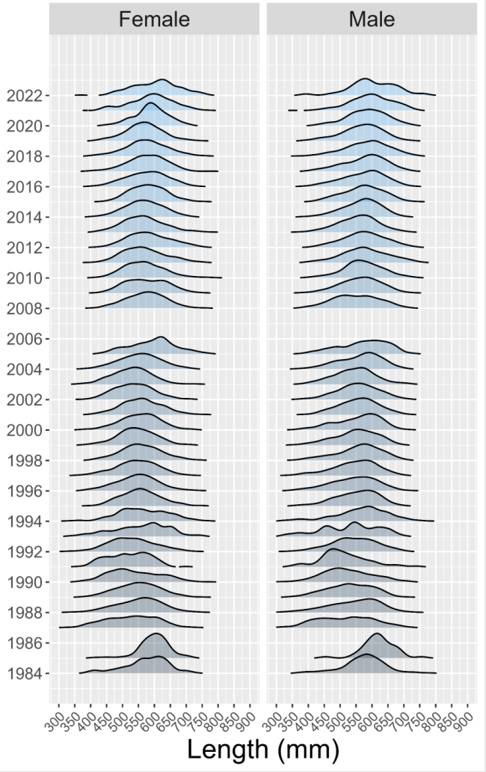

Figure 2: Age, length, and observed age

Moving from a biomass-only model to use of an additional index, CPUE calculated from the IPHC FISS (longline survey designed for halibut) in which yelloweye is also caught, requires some *a priori* consideration of the likely validity and reliability of the CPUE as an index by sub- or overall-area of yelloweye stock size. Joy *et al* (2022) justify the potential use of FISS-derived CPUE and reasonably respond to likely concerns. It would be possible to debate details of the filtering, but the final index is unlikely to be very different to that presented to the REMA implementation. Working with IPHC scientists, Joy *et al* (2022) have developed a CPUE series from 1998-2021 that is at least usable/testable within the REMA (Sullivan *et al*, 2022) framework before also potentially using it within an SPM (see graphic below, right hand panels) (Figure 3).

The absolute biomass estimate from ROV surveys is tied to final years of sampling by area. An overall biomass estimate therefore needs to be derived using some form of smoothing and projection. A simple random effects (RE) or random effects model (REM) method could be applied for this purpose. Status quo estimates of biomass using submersible/ROV only were made by Joy *et al* (Model 21.1) but these were not considered in the review. The Model 21.1 estimates appear higher than those made using REMA (Figure 14.1 of Joy *et al*) but it is unclear how this can be, given sparsity of recent ROV data and an apparent increase in CPUE in recent years across areas (rhs of graphic below). Models including IPHC CPUE would be expected in general to estimate higher terminal biomass than models without it.

The REMA development includes comparison of models with and without IPHC data included. Table 14.9 of Joy *et al* (2022) shows for Models 22.4 and 22.5 (biomass only, no IPHC CPUE) estimates of biomass made without including extra observation error. Model 22.4 is process error only and estimates a high process error, consistent with the variable biomass estimates, especially in the early years of submersible surveys (see figures below outlined in red). Model 22.5 includes extra observation error, naturally resulting in a greatly reduced process error estimate. Regardless of how the process and observation errors are weighted, the biomass estimates are close (17,765 tonnes vs 17,986 tonnes). Both are below *status quo* estimates from Model 21.1.

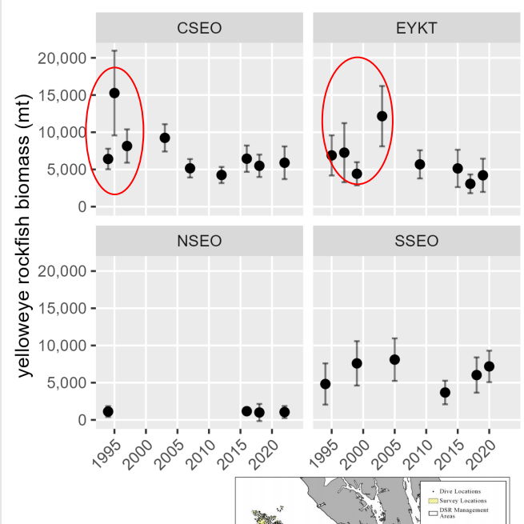

Figure 3: Figures copied from presentation to review meeting. Left hand panel shows submersible/ROV-derived biomass estimates. Right hand panels show yelloweye CPUE in FISS as filtered by Joy et al (2022).

The model fits to data are shown by area by Joy *et al* but not clearly for the entire area, for which results are only shown without data (see graphic below). Comparing model 22.4 and 22.5 (orange and light blue), adding observation error smooths the estimates through time (as expected), especially losing the apparent increase in biomass indicated by the data in the period *circa* 2000. With little or no data to work with in recent years, the 2022 estimate of biomass is near identical for the two models (though different to Model 21.1). There is simply no information to do otherwise. Given the need to estimate biomass for OFL decision-making, making use of more current information such as the IPHC CPUE as an index would be a logical next step if those data are valid and reliable.

No REM fitting was performed on only the IPHC CPUE (i.e., with no submersible/ROV biomass estimates). The CPUE by area (see the graphic above, right hand panel) suggests that there may be some increase in biomass in recent years, notably in areas CCSEO and perhaps SSEO. There is, therefore, an *a priori* expectation that adding the CPUE index would result in a higher estimate of current biomass than using the biomass data only (depending on the degree of smoothing). As no REM was fit with CPUE data only, this is speculation. It would be good to see REM results.

Joy *et al* moved directly to the REMA, incorporating all biomass estimates, multiple areas, and the additional CPUE index. For comparison with Models 22.4 and 22.5, models 22.1 and 22.2 were fit (i.e., without and with additional observation error; see next graphic) (Figure 4).

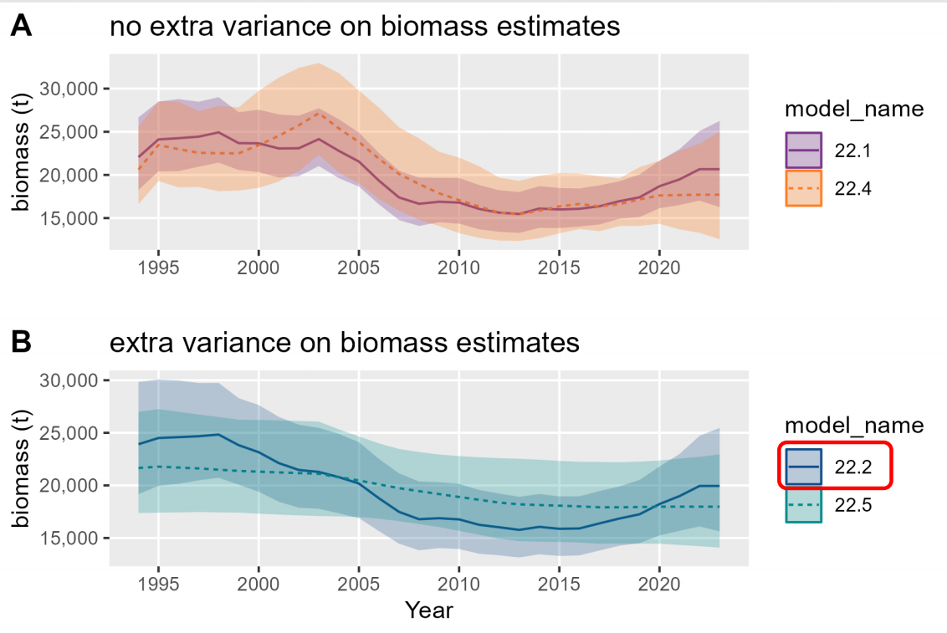

Figure 4: Biomass estimates with and without extra variance on biomass estimates.

For the REMA implementation using both submersible/ROV-derived, sparse, absolute biomass estimates and annual CPUE as an index, Models 22.1 and 22.2 (where 22.2 has additional observation error) both show more annual variation as the annual index data influence the smoothing. Both models also apparently estimate biomass in 2022 to be greater than with the biomass data only (REM models 22.4 and 22.5). This is inconsistent with table 14.9 of Joy et al 2022) which shows all models estimating very similar biomass in 2022. The graphical interpretation is in line with *a priori* expectation. It would be good to check the biomass estimates in table 14.9 before they are used in any Tier 5 OFL calculation.

The use of REMA is in line with recommendations in Sullivan *et al* (2022) and the implementation and results to date are appealing. The ROV surveys are cyclic by sub-area and prone to logistical and technical disruption. The methods used to estimate biomass from the surveys are well-known and potentially provide a reliable absolute biomass estimate or, at least, a good perspective on minimal absolute biomass for scaling REMA or an SPM. The use of the IPHC CPUE as an index potentially adds good information on annual variations in biomass and especially on recent trends that can feed in to improved biomass estimation when setting OFLs. Whether or not the CPUE can provide a consistent and reliable index is hard to determine. There are multiple concerns, but these seem generally to be allayed. The choice of Model 22.2 for OFL setting is reasonable but the 2022 estimate at table 14.9 needs to be checked considering the results shown graphically during review and the model 21.1 results.

In the absence of an age-structured, analytical assessment model, use of a surplus production model (SPM) may be useful to guide OFL setting. However, it is unclear how this would fit within the current NPFMC Tier system. SPM are used for long-lived species such as yelloweye rockfish within other jurisdictions (see, e.g., Lart, 2022) though the legal basis and governance may be different. In order to fit an SPM, data on catches need to be considered.

During the review, a brief overview on catches from 1980 onwards was provided, introduced using a summary slide (Figure 5). Joy *et al* (2022) provides more detail.

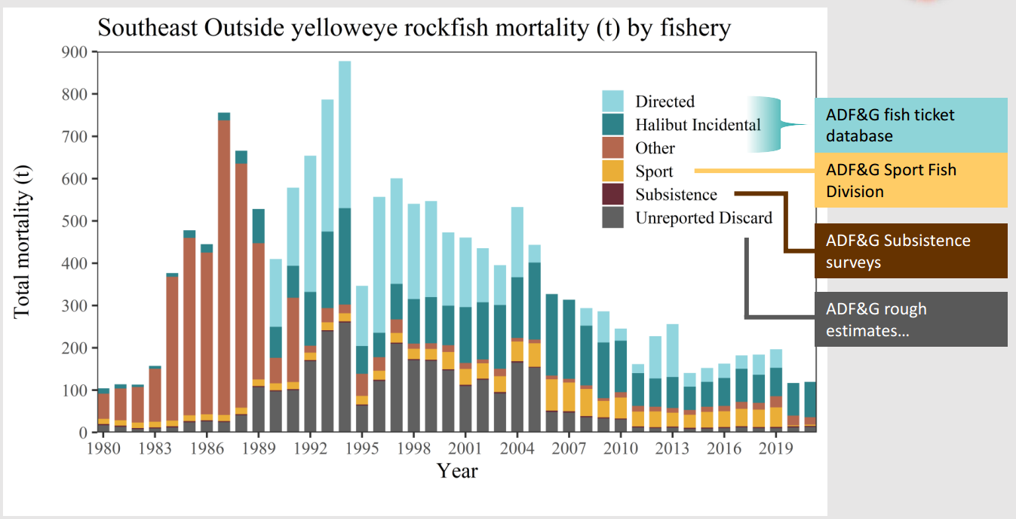

Figure 5:SEO yelloweye rockfish mortality by fishery summary

It is beyond this review to consider the multiple federal and state systems in place now and since various start times. The various catch sources are reliable from different dates as fishery changes and reporting requirements have come into force. The commercial statistics are to be fully reviewed prior to the 2024 assessment, as reported by Joy *et al* (2022) and during the review. This is an important step if an SPM or age-based method is to be developed and used to inform management. The concern here is to understand the reliability of catches as might be used for SPM fitting, both post 1980 and possibly from 1925 onwards, including the period of foreign catches from 1960 to 1987. The catch figures plotted above for 1980 onwards show a high degree of variability by type through time. Post 1992 most of these figures are likely reliable but two issues could be clarified. First, how are the ADF&G “rough estimates” made? This was unclear during review. Also, how is “other” calculated for 1980 onwards? In Joy *et al* (2022), “other” removals are defined as subsistence, research, and recreational removals. Picking out 2003 as an example, Table 14.2 of Joy *et al* (2022) suggests these removals are 8+6+48=62 tonnes. But the figure above suggests a smaller amount. Table 14.2 only starts from 1992 and it is unclear what the 1980-1991 rust coloured bars in the figure represent. I have checked if they represent estimated bycatch (ToR 3) but from the figures shown during review (slide 63) this does not seem to be the case (comparing, e.g., 1987). They are also not ADF&G estimated foreign catches as can be seen by reference to Table 14.6 of Joy *et al* (2022).

I have probably missed something important, but it is necessary to clarify exactly how removals have been estimated/calculated. Table 14.2 relates to DSR rather than yelloweye and I have likely missed a distinction on the definition of “other” for the yelloweye specifically – but I cannot find that in the presentation or in Joy *et al* (2022). The SPM works from 1980 to develop priors for final fitting of data from 1925 onwards. Problematically, in order to estimate productivity parameters, the SPM needs to extract information from biomass and index data on change and ideally the MSY inflection point (i.e., it needs to “see” contrast in biomass and index data in response to changes in catch and fishing effort). Regardless of the removals data, the biomass survey is only from 1994 and the CPUE data from 1998. The early biomass survey data are arguably unreliable given the unlikely large changes in biomass estimates and the survey CPUE data are quite flat over the majority of the time series. Visual inspection of the biomass and survey CPUE series by area (side by side panels above) do not suggest consistency of information from the two series. For CSEO, biomass estimates may decrease but CPUE is flat or increasing; for NSEO, biomass data are sparse but flat while the CPUE are flat but variable; for EYKT, biomass may be declining slightly while CPUE are flat or slowly increasing since *circa* 2003; for SSEO, biomass estimates are flat, but the CPUE may show a slight decrease and then increase. During the same period, catches have decreased or stabilized low (from circa 500 tonnes per year to 200 tonnes per year) as fishing effort has also decreased so there may be some information on productivity during this period, though there have been changes in fishery exploitation pattern and the data period is short compared to the species longevity, and environmental and species assemblage changes may also have impacted on productivity. The annual removals increased and decreased during the 1980 onwards period but are small compared to the minimum estimated biomass (200-500 tonnes per year compared to 20,000 tonnes biomass – roughly, mortality of 0.01-0.025 cf M of 0.02 or likely greater considering the range of estimates in green *et al*, 2015).

Without even looking to model selection, development, and fitting, and certainly in the absence of any simulation testing, it is difficult to expect from first principles that an SPM would add valuable information to the management process. Two things still need to be considered at this ToR. First, how would SPM outputs be used within the Tier system, or a modified system. Second, model development and fitting to date.

The Tier system is described in the 2020 FMP, including a brief history/explanation of the NPFMC implementation. By requirement, the FMP, including the Tier system, are in accordance with the MSFMA (1996) and all relevant National Standards (NS), including for NS1 which guides the formulation of the Tier system. For the NPFMC, the system aligns with its overall F40 harvest policy. Review of the F40 harvest policy in 2002 (Goodman *et al*, 2002) noted the importance of the F40% construct for Tiers 2-4, including the use of FOFL set to FMSY or a proxy (F35%), and how Tier 5 differs in the attempt to approximate MSY-related management. Because M is theoretically higher than FMSY, the margin between the FOFL and FABC is increased to 25%, rather than using an analytically derived reduction as at Tiers 1-4. Some caveats were raised about long-lived species such as rockfish, and on single-species MSY-based management approach in a multi-species or ecosystem context. Nevertheless, for stocks for which no analytical assessments are available, Tier 5 was considered to be a precautionary approach, consistent with legislative and policy requirements.

SPM approaches are not envisaged or supported within the current Tier system, though arguably Tier 5 could be modified to use a direct estimate of FMSY from SPM instead of an estimate of M. However, the use of FABC=0.75FOFL would need to be reconsidered and new guidance written into the FMP at section 3.2.3.3.1. It is not obvious how this would be done to provide equivalence with FABC settings when M is used at Tier 5, or with other Tiers. Simulation using an age-based operating model (OM) would be necessary (ToR 4). Unless SPM were to be used for many species, it is not clear that modifying the Tier system would be a worthwhile exercise to accommodate just yelloweye rockfish unless, for example, its importance as a potential choke species in the halibut fisheries was a factor. From a scientific perspective, it would be interesting, but from a management or science planning perspective it could be disruptive and expensive. That is beyond the scope of this review. However, one advantage of using an SPM in place of a simple biomass-based Tier 5 approach is that objective risk-based forecasting would be possible.

My expectation is that changing the Tier system to accommodate SPM-based estimates of FMSY and biomass will not be done quickly and that in 2024, FOFL and FABC setting will need to progress under the current system. Whether it is worth developing the SPM for yelloweye rockfish is a decision to be made in the context of other requirements and staff availability and focus. Also needing to be considered is the likelihood of a SPM being deemed reliable given the uncertainty of multiple sources of removals historically and even from 1980. Only for the period 1998 onwards is there a period of reasonable overlap between biomass estimates, biomass index, and sufficiently certain removals. The biomass estimates in that time show larger than expected variations. There is little visual signal in either biomass or CPUE over the period, though catches did decline and stabilize. There is possibly little to inform productivity estimates during the period.

SPM model fitting to date has been explored using a state-space implementation of a Pella-Tomlinson (P-T) model fixed so that BMSY=B40. This is an attempt to emulate the F40 harvest policy and current Tier settings at Tiers 2-4. However, at Tier 4, FMSY is assumed as F35 and used for OFL setting, with F40 being used for ABC setting in line with achieving OY. More importantly, setting BMSY=B40 in the P-T model does not guarantee equivalence with the SPR approach used at Tiers 2-4. Winker *et al* (2020) demonstrate through simulations using an age-based operating model (OM) that for specific life history and selectivity (white marlin, where length at 50% maturity is greater than length at 50% selection) a P-T model may estimate exploitable B/B0 greater than spawning B/B0. In the words of Winker *et al*, exploitable biomass behaves hyper-stable relative to spawning biomass while biomass is declining. Winker *et al* do not go beyond simulation testing the SPM relative to known underlying age-based dynamics for which an age-based assessment model can reasonably capture those underlying dynamics. They do not perform MSE and test management procedures (MP) as a way of managing effectively in the face of SPM estimation performance.

The Winker *et al* simulation is for white marlin, with Mat50 > Sel50. From Green *et al* (2015) yelloweye Mat50 is circa 17-18 years and Sel50 (estimated) is near 20 years (Green *et al*, Fig.19). Yelloweye is also longer lived with lower M. The simulation results of Winker *et al* cannot be immediately carried over for yelloweye. However, they point strongly to the need for caution in adopting a specific SPM without checking that it is likely to achieve equivalence of the spawning-related reference points used in the NPFMC Tier system.

Given data uncertainties pre-1980 and likely environmental and ecosystem change impacting on effective definition of unexploited biomass, fitting an SPM to 1980 onwards might be a good starting point. Even so (e.g., ToR 3), estimates of removals are uncertain, especially pre-2000). If the 1980 onwards estimates of removals reasonably capture increases and decreases in catch, then changes (possible responses) in the 1998 onwards biomass estimates and CPUE index may allow information on productivity to be extracted.

With regard to the questions posed at ToR 1: *Specifically, determine if results suggest that the NPFMC Tier 5 approach is appropriate; and should biomass estimates from such a model be used in place of the survey average method currently used for most Tier 5 stocks managed by the NPFMC?* If Tier 5 management is used then biomass estimates are required and need to be as accurate and timely as feasible. The ROV-based estimates are always a combination across areas sampled on a 4-year rolling basis and are always therefore lacking in recency. Using CPUE and the REMA approach is a valid way of estimating as best possible the most recent biomass to be used in TAC setting. Use of an SPM adds little to the estimation of recent biomass but may in principle ensure consistency of an Fmsy estimate with the estimated biomass. However, there will be uncertainty in any such estimate, and it is not immediately obvious that there will be a benefit compared to the current approach using an estimate of M. Updating and improving the estimate of M is overdue and should be done.

**ToR 2** *Evaluate the management of the GOA demersal shelf rockfish complex as a whole including examination of the use of available data for species other than yelloweye rockfish and determination of Tier level designations.*

This ToR was not considered at length during the review and there was no discussion on the stocks/catches other than for yelloweye rockfish.

For yelloweye rockfish, comprising greater than 90% of the DSR catch, there is a reliable estimate of biomass as required at Tier 5 and an estimate of M is used to determine FOFL, also as required at Tier 5. As noted above (ToR 1), the estimate of M is not well justified, and it seems to be low compared to many derived estimates. This is under review and there is little to add other than the approach is well tried and tested and the 0.75 multiplier to calculate FABC accounts for M being theoretically greater than FMSY. The difference in biomass estimates between the REMA models and Model 21.1 might be checked.

For other DSR species there is only catch information. Setting FOFL and FABC by species and summing them seems reasonable, as long as the distribution and relative frequency of landings remains constant for all DSR species. The use of the maximum catch by species from 2010-2014 is justified in Joy *et al* (2022) as being for the only years available. It is not obvious how this relates to the Tier 6 requirements for basing the OFL calculation on an average catch for a given period “*unless an alternative value is established by the SSC on the basis of the best available scientific information*”. No reference is made to an SSC decision on this but I presume the practice was established by the SSC?

More generally, setting ABC based on a 0.75 multiplier of average catch can only lead to reducing ABC over time if catches are actually constrained by the ABCs. In contrast, using the maximum catch by stock over a period when the catch may be unconstrained due to a combined, larger DSR ABC which includes yelloweye, could in principle lead to increasing stock-specific ABC over time. Whether or not combining the ABC for all species is reasonable will depend on the specifics of exploitation pattern(s), fisheries management, and biology/ecology of the species.

**ToR 3** *Review the methods used for estimating yelloweye bycatch in the directed Pacific halibut fishery and for estimating total yelloweye catch removals.*

For SPM usage, Joy *et al* (2022) Appendix A describes methods used to reconstruct annual expected bycatch and, by subtraction of recorded landings, discards. The approach is intended to supply the best possible information on removals, including uncertainty, to the SPM but is not presented for other purposes. Given major uncertainties in other removals, especially foreign catches between 1961-1974), it is important to keep this in mind and it is clear from the risk analyses conducted (see e.g. Joy *et al*, 2022, Table 14.A5) that bias in estimates of discards is important in estimating reference points. Review of the methods should not be focused on whether the bycatch estimation method gives an accurate estimate of bycatch (and hence discards) but rather on does it provide an adequate basis, including treatment of uncertainty (by risk analysis), to allow credible and practical SPM fitting.

The methods used rely on annual, by-station estimation of yellowfin CPUE per effective hook and, given the number of hooks, the catch by number of yellowfin per station. To derive an estimate of yellowfin bycatch (by weight) to landed halibut (by weight) by SEO area, yellowfin CPUE by station were multiplied by SEO area-specific landed commercial yelloweye weights (EQN 11 of Joy *et al*) and then divided by the average weight of legal sized halibut by survey station. In principle, this leads to an annual, by SEO area, estimate of survey-informed, expected bycatch of yelloweye. It is unclear why the yelloweye weights are taken as landed commercial weights by area instead of directly from the survey stations for direct comparison to the legal sized halibut weights. This needs to be better explained and justified. It is unclear especially given that the survey starts in 1998 and full retention for landing started only in 2005 and partial retention in 2000 (and full observer coverage only in 2013).

Regardless, the method is in principle a way of directly using survey data from 1998 onwards to estimate annual bycatch rates by SEO area. Whether those estimates are credible, and how uncertainty is estimated/treated needs to be considered prior to model fitting. Given non-normality and large numbers of stations with zero yelloweye catch, non-parametric bootstrapping has been used to estimate relevant quantities. This is reasonable and the approach taken to use area bycatch rate, and long-term (1998-2001) means for application to 1980-1997 is also reasonable. The use of inflated (maximum) CVs for the 1980-1997 period is reasonable for the purposes of fitting the SPM. It is not explicit in the assessment document but presumably for stage 3 SPM fits to pre-1980 data, the same approach was taken. It is also not explicit how SEO area bycatch rate estimates are raised to a total estimate as in Figure 14.A2.

Whether the estimates are credible is hard to determine formally. Figure 14.A2 does suggest that the whole area estimate of bycatch rate is reasonably aligned with the rate estimated through the NOAA observer program starting in 2013. The scale of Figures 14.A3 in unhelpful but expected bycatch by SEO area (graphic below) suggest that bycatch estimates are often below reported landings so that bycatch in those years will be presented to the model as landings plus zero (or 1 tonne) discards. For the period 2000 onwards this is in line with full retention requirements but the frequency of estimation below that observed, which must be a minimum expectation, suggests the applied method may not be capturing the bycatch generation process as well as hoped.

Of further concern, as an example, is the high expected bycatch in 1998, notably in the CSEO and EYKT and possibly in the NSEO. The sum (by visual inspection) of expected bycatch estimates across areas is of the order of 400 tonnes. Directed and incidental landings that year were 241 tonnes and 119 tonnes respectively (Table 14.2). The landed bycatch in the figure, summed across areas, appears in line with the incidental catch of 119 tonnes but the very high expected bycatch substantially exceeds the directed catch of 241 tonnes. The area wide bycatch rate is shown in Figure 14.A2 and is about 0.06 while the CSEO bycatch rate is about 0.12 as shown in Figure 14.A1 (Figure 6; Figure 7). Even while the 1998 CSEO bycatch rate estimate is high, for all other areas it is low. How can the estimate of bycatch be so large?

Presuming the estimates have been well calculated/estimated, then within the SPM fitting, to further investigate and reveal the effects of uncertainty, which is recognized to be high, Joy *et al* (2022) undertook risk analyses where the estimated bycatch rates were reduced or increased effectively by 30% (Table 14.A5). The approach is reasonable given the difficulties associated with the estimation process and is pragmatic though subjective.

Overall, the bycatch estimation approach is probably sufficiently right to use alongside other uncertain sources of removals in exploring SPM development, so long as uncertainties are recognized and investigated. The credibility of estimated bycatch reduces substantially prior to 1980. The use of inflated CVs and risk analysis is a practical way to do this. An explanation would be helpful about why landed yelloweye weights are used instead of survey weights and how this might affect estimates. Presumably, mean landed weights are greater than mean survey weights (as smaller fish are more likely to be discarded). If this is so, then an alternative approach might be to estimate discards by comparing length distributions from landed fish and the survey by SEO area (see e.g., Heath and Cook, 2015).

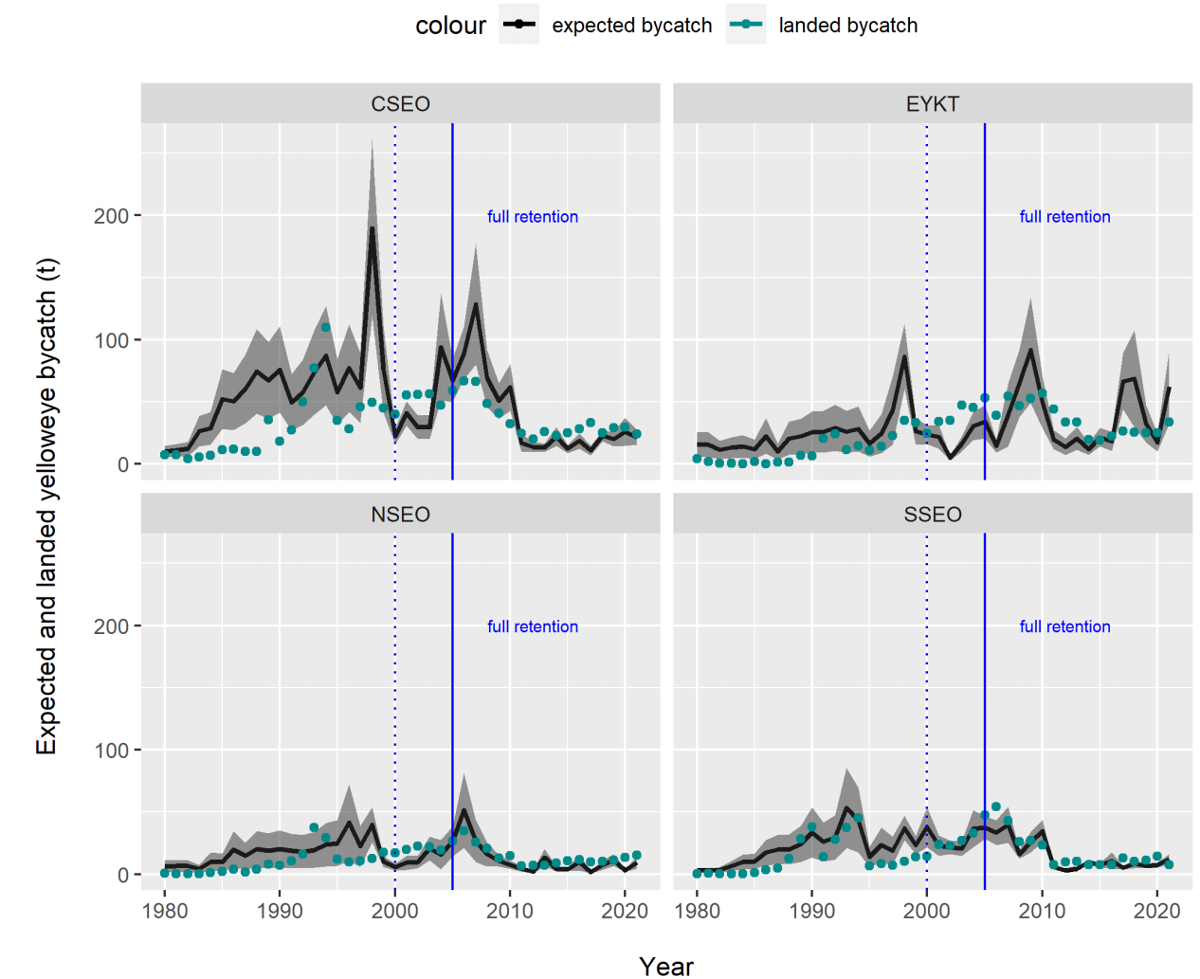

Figure 6: Expected and landed yelloweye rockfish bycatch by region.

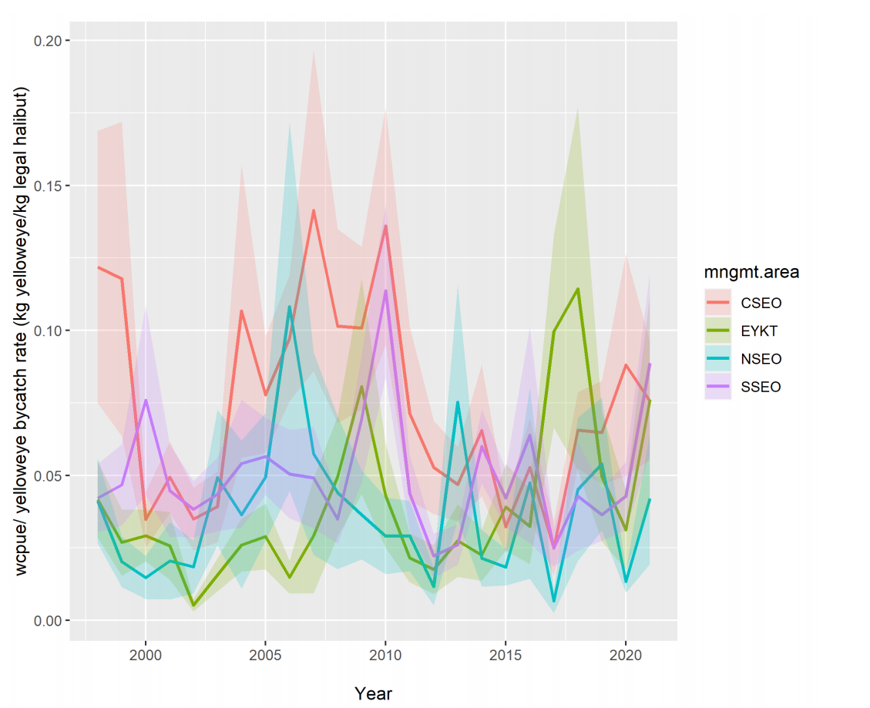

Figure 7: Yelloweye rockfish bycatch rate by management area.

**ToR 4** *Provide advice and recommendations on a framework for simulation testing the surplus production model to evaluate similarities between this application of surplus production models and age-structured methods typically used in the North Pacific Fishery Management Council Tier management system.*

The motivation and intent of the ToR is unclear. Discussion during the review meeting was not conclusive as to whether the request is for advice on simulation testing of SPM approaches *cf.* age-structured approaches “typically” used in the NPFMC Tier management system, with possible consequential general modification of the system, or for just the yelloweye rockfish specific SPM being developed by Joy *et al* (2022) *cf.* typically used age-structured methods. The issue is complicated not just by confusion over specific *versus* generic but also because there is no finalised version of “this application…” and no clarity as to what is typical.

Modification of the Tier system would presumably require extensive management strategy evaluation (MSE) and is apparently beyond the scope of the review.

Simulation testing of a yet-to-be finalised yelloweye P-T SS-SPM could be done to test equivalence with an age-structured model as “typically” used, though it is unclear as to what purpose this would achieve. The obvious starting place for testing would be to develop operating models (OM) using an available framework such as ss3sim (<https://cran.r-project.org/web/packages/ss3sim/vignettes/introduction.html>). However, given the difficulty with past development of an age-structured model for yelloweye rockfish (Green *et al*, 2015), and major uncertainties in multiple L-H inputs and catch histories, any base OM would need to capture considerable process and observation error. Further, fitting a benchmark age-structured model to the OM against which to compare the SPM would be open to debate. It is not clear how this would assist in the development of a yelloweye SPM or how it would help in implementing results from an SPM into the Tier system.

If an SPM is to be developed then it is more pressing in the short term to develop a model that is regarded as sufficient to capture the dynamics of the yelloweye stock in a way that is suitable to inform management. The question of then using the SPM in decision-making is moot. Without MSE to test efficacy of SPM within the Tier system more generally, it is hard to see how an SPM just for yelloweye would in any case be used. The model presented in Joy *et al* (2022) is a complete model, fitting to everything all at once and with multiple uncertainties. It would be helpful to use a “yelloweye-like” simulated data set (using, e.g., ss3sim) to test step-wise development from ROV, CPUE-only, ROV+CPUE, ROV+catch, etc…to validate a final SPM approach which can then be applied to the real yelloweye data. This would not be a comparison of the SPM with typically used age-structured methods, but it would allow SPM development with a known basis. As part of this work, development of the stock-specific production parameters could follow the approach of Winker *et al* (2020).

**CONCLUSIONS AND RECOMMENDATIONS**

*The main body of the reviewer report shall consist of a Background, Description of the Individual Reviewer’s Role in the Review Activities, Summary of Findings for each TOR in which the weaknesses and strengths are described, and* ***Conclusions and Recommendations in accordance with the TOR.***

The review of Gulf of Alaska Demersal Shelf Rockfish Assessment is focused on new methods for assessing yelloweye rockfish. The ToR are somewhat unusual for a CIE review and are somewhat confusing. The review meeting helped to clarify the motivation for the ToR. The focus is on the new methods (REMA and an SPM) for assessing yelloweye rockfish. Until 2022, OFL and ABC have been set using Tier 5 of the NPFMC Tier system, with biomass estimates derived from submersible/ROV surveys and an estimate of M.

If Tier 5 management is used, then biomass estimates are required and need to be as accurate and timely as feasible. The ROV-based estimates are always a combination across areas sampled on a 4-year rolling basis and are always therefore lacking in recency. Using CPUE from the IPHC FIS and the new REMA approach is a valid way of estimating as best possible the most recent biomass to be used in OFL setting. Use of an SPM adds little to the estimation of recent biomass but may in principle ensure consistency of an Fmsy estimate with the estimated biomass. However, there will be uncertainty in any such estimate, and it is not immediately obvious that there will be a benefit compared to the current approach using an estimate of M. The estimate of M currently used is not well justified, and it seems to be low compared to many derived estimates. Updating and improving the estimate of M is overdue and should be done.

For yelloweye rockfish, comprising greater than 90% of the DSR catch, there is a reliable estimate of biomass as required at Tier 5 and an estimate of M is used to determine FOFL, as required in the FMP. The Tier 5 approach is well tried and tested and the 0.75 multiplier to calculate FABC accounts for M being theoretically greater than FMSY. For other DSR species there is only catch information. Setting FOFL and FABC by species and summing them seems reasonable, as long as the distribution and relative frequency of landings remains constant for all DSR species. The use of the maximum catch by species from 2010-2014 is justified as being for the only years available. It is not obvious how this relates to the Tier 6 requirements for basing the OFL calculation on an average catch for a given period “*unless an alternative value is established by the SSC on the basis of the best available scientific information*”. No reference is made to an SSC decision on this.

Overall, the bycatch estimation approach is probably sufficiently right to use alongside other uncertain sources of removals in exploring SPM development, so long as uncertainties are recognized and investigated. The credibility of estimated bycatch reduces substantially prior to 1980. The use of inflated CVs and risk analysis is a practical way to do this. An explanation would be helpful about why landed yelloweye weights are used instead of survey weights and how this might affect estimates. Presumably, mean landed weights are greater than mean survey weights (as smaller fish are more likely to be discarded).

If an SPM is to be developed for yelloweye, then it is more pressing in the short term to develop a model that is regarded as sufficient to capture the dynamics of the yelloweye stock in a way that is suitable to inform management. The question of then using the SPM in decision-making is moot. Without MSE to test efficacy of SPM within the Tier system more generally, it is hard to see how an SPM just for yelloweye would in any case be used. The model presented in Joy *et al* (2022) is a complete model, fitting everything all at once and with multiple uncertainties. One way forward would be to use a “yelloweye-like” simulated data set (using, e.g., ss3sim) to test stepwise development of data inclusion to validate a final SPM approach which can then be applied to the real yelloweye data. This would not be a comparison of the SPM with typically used age-structured methods, but it would allow SPM development with a known basis.

**APPENDIX 1**

*The reviewer report shall include the following appendices:*

*a. Appendix 1: Bibliography of materials provided for review*

**Bibliography of materials provided for review**

Materials provided in advance included a full set of presentation slides (sent via e-mail) as well as referencxes as outlined in Appendix 2:

* Joy et al. 2022. 14: ASSESSMENT OF THE DEMERSAL SHELF ROCKFISH STOCK COMPLEX IN THE SOUTHEAST OUTSIDE SUBDISTRICT OF THE GULF OF ALASKA . https://apps-afsc.fisheries.noaa.gov/Plan_Team/2022/GOAdsr.pdf
* September, 2022 GOA Groundfish Plan Team Minutes (page 3) https://meetings.npfmc.org/CommentReview/DownloadFile?p=32eee72a-2fc4-46f6-bd2b-9011ea8e3577.pdf&fileName=C5%20GOA%20Groundfish%20Plan%20Team%20Minutes.pdf
* October, 2022 NPFMC SSC Minutes (page 23) https://meetings.npfmc.org/CommentReview/DownloadFile?p=d95d28fe-3540-4e74-baa3-f029ce6a3a7d.pdf&fileName=SSC%20Report%20Oct%202022_Final.pdf
* November, 2022 NPFMC GOA Groundfish Plan Team Minutes (page 6) https://meetings.npfmc.org/CommentReview/DownloadFile?p=39d6577b-136c-49e4-b17e-03dd78659c41.pdf&fileName=C5%20GOA%20Groundfish%20Plan%20Team%20Minutes%20November%202022.pdf
* December, 2022 NPFMC SSC Minutes (page 46) https://meetings.npfmc.org/CommentReview/DownloadFile?p=d94f4b3e-7e21-4e4f-92fd-e39141acfc4a.pdf&fileName=SSC%20Report%20Dec%202022_DRAFT%20to%20COUNCIL.pdf
* Management advice provided by NPFMC stock assessments conforms to specified harvest control rules. The NPFMC uses an Overfishing Control Rule (OFL) referred to as the “Tier System”. Any model output or management advice must provide reference points applicable to these harvest control rules. https://www.npfmc.org/fisheries-issues/fisheries/goa-groundfish-fisheries/

Additional references are:

* Fishbase entry *https://www.fishbase.se/summary/Sebastes-ruberrimus*
* Cox, S.P., Doherty, B., Benson, A.J., Johnson, S.D.N., and Haggarty, D.R. 2020. Evaluation of potential rebuilding strategies for Outside Yelloweye Rockfish in British Columbia. DFO Can. Sci. Advis. Sec. Res. Doc. 2020/069. viii + 135 p.
* Buckland, S. T., D. R. Anderson, K. P Burnham, and J. L. Laake. 1993. Distance sampling: estimating abundance of biological populations. Chapman & Hall. London. 446 p.
* Gertseva, V. and Cope, J.M. 2017. Stock assessment of the yelloweye rockfish (*Sebastes ruberrimus)* in state and Federal waters off California, Oregon and Washington. Pacific FisheryManagement Council, Portland, OR. Available from [*http://www.pcouncil.org/groundfish/stockassessments/*](http://www.pcouncil.org/groundfish/stockassessments/)
* Gertseva, V., Cope, J. M. 2018. Rebuilding analysis for yelloweye rockfish (*Sebastes*

*ruberrimus*) based on the 2017 stock assessment. Pacific Fishery Management Council,

Portland, OR. Available from [*http://www.pcouncil.org/groundfish/stock-assessments/*](http://www.pcouncil.org/groundfish/stock-assessments/)

* Goodman, D., G. Thompson, M. Mangel, T. Quinn, T. smith, G. Parks, V. Restrepo, K. Stokes 2002. Available at: <https://meetings.npfmc.org/CommentReview/DownloadFile?p=0a8954b9-dbf8-40e0-a4c8-b4e422bc6242.pdf&fileName=D1(a)%20F40%20Independent%20Review.pdf>
* Heath MR, Cook RM. 2015. Hind-Casting the Quantity and Composition of Discards by Mixed Demersal Fisheries in the North Sea. PLoS ONE 10(3): e0117078. Available at: <https://doi.org/10.1371/journal.pone.0117078>
* Lart, W. 2022. Guide to Fishing at Maximum Sustainable Yield (MSY). Seafish SR743 Version 2 February 2022, Available at: <file:///C:/Users/kevin/Downloads/Guide%20to%20Fishing%20at%20Maximum%20Sustainable%20Yield%20(MSY).pdf>
* Sullivan, J., C. Monnahan, P. Hulson, J. Ianelli, J. Thorson, and A. Havron. REMA: a consensus version of the random effects model for ABC apportionment and Tier 4/5 assessments. Available from: <https://meetings.npfmc.org/CommentReview/DownloadFile?p=eaa760cf-8a4e-4c05-aa98-82615da1982a.pdf&fileName=Tier%204_5%20Random%20Effects.pdf>
* Winker, H., B. Mouato, and Y. Chang. 2020. Unifying parameterizations between age-structured and surplus production models: an application to Atlantic white Marlin (*kajikia albida*) with simulation testing. *Collect. Vol. Sci. Pap. ICCAT, 76(4): 219-234(2020)***APPENDIX 2**

*The reviewer report shall include the following appendices:*

*b. Appendix 2: A copy of the CIE Performance Work Statement*

**Performance Work Statement**

**National Oceanic and Atmospheric Administration (NOAA)**

**National Marine Fisheries Service (NMFS)**

**Center for Independent Experts (CIE) Program**

**External Independent Peer Review**

**Gulf of Alaska Demersal Shelf Rockfish Assessment**

* 1. **Background**

The National Marine Fisheries Service (NMFS) is mandated by the Magnuson-Stevens Fishery Conservation and Management Act, Endangered Species Act, and Marine Mammal Protection Act to conserve, protect, and manage our nation’s marine living resources based upon the best scientific information available (BSIA). NMFS science products, including scientific advice, are often controversial and may require timely scientific peer reviews that are strictly independent of all outside influences. A formal external process for independent expert reviews of the agency's scientific products and programs ensures their credibility. Therefore, external scientific peer reviews have been and continue to be essential to strengthening scientific quality assurance for fishery conservation and management actions.

Scientific peer review is defined as the organized review process where one or more qualified experts review scientific information to ensure quality and credibility. These expert(s) must conduct their peer review impartially, objectively, and without conflicts of interest. Each reviewer must also be independent from the development of the science, without influence from any position that the agency or constituent groups may have. Furthermore, the Office of Management and Budget (OMB), authorized by the Information Quality Act, requires all federal agencies to conduct peer reviews of highly influential and controversial science before dissemination, and that peer reviewers must be deemed qualified based on the OMB Peer Review Bulletin standards[1]. Further information on the Center for Independent Experts (CIE) program may be obtained from [www.ciereviews.org](http://www.ciereviews.com).

* 1. **Scope**

The stock assessment for Demersal Shelf Rockfish Complex in the Southeast Outside Subdistrict of the Gulf of Alaska provides the scientific basis for the management advice considered and implemented by the North Pacific Fisheries Management Council. This stock assessment is conducted by the State of Alaska in partnership with the Alaska Fisheries Science Center (AFSC) and provides management advice in the federally regulated Gulf of Alaska Fishery Management Plan. An independent review of this stock assessment is requested by the Alaska Fisheries Science Center’s (AFSC) Auke Bay Laboratories Division (ABL) and the Alaska Department of Fish and Game (ADF&G). The goal of this review will be to ensure that the stock assessment represents the best available science to date and that any deficiencies are identified and addressed. In 2022, the stock assessment authors introduced new methodologies for assessing a major component species of the DSR complex, yelloweye rockfish. Review of these new methods and their application to the North Pacific Fishery Management Councils (NPFMC) harvest control rules are requested. The specified format and contents of the individual peer review reports are found in Annex 1. The Terms of Reference (TOR) of the peer review are listed in Annex 2. Lastly, the tentative agenda of the panel review meeting is attached in Annex 3.

**Requirements**

NMFS requires three (3) reviewers to conduct an impartial and independent peer review in accordance with the PWS, OMB guidelines, and the TOR below. The reviewers shall have a working knowledge and recent experience in the application of complex stock assessment methods and in particular application of Bayesian state-space surplus production models (SSSPM).

Additionally, the CIE reviewers shall have:

* Expertise with measures of model fit and evaluation, uncertainty, forecasting, and biological reference points;
* Expertise in the application of surplus production models in providing management advice;
* Familiarity with Alaska groundfish fisheries and management;
* Familiarity of the assessment and management of stock complexes;
* Working knowledge of the use of fishery and survey data in stock assessment;
* Familiarity with North Pacific Fishery Management Council harvest control rules and determination of reference points used in Alaska fisheries management;
* Excellent oral and written communication skills to facilitate the discussion and communication of results.

**Tasks for reviewers**

1. Review the following background materials and reports prior to the review meeting. Two weeks before the peer review, the NMFS and ADF&G Project Contacts will make all necessary background information and reports available electronically for the peer review. In the case where the documents need to be mailed, the NMFS Project Contact will consult with the CIE on where to send documents. The CIE reviewer shall read all documents in preparation for the peer review.
2. Attend virtually and participate in the panel review meeting. The meeting will consist of presentations and discussions with the ADF&G stock assessment authors, NMFS staff, and supporting experts of fishery and survey information to facilitate the review.
3. After the review meeting, reviewers shall conduct an independent peer review report in accordance with the requirements specified in this PWS, OMB guidelines, and TOR, in adherence with the required formatting and content guidelines; reviewers are not required to reach a consensus.
4. Each reviewer should assist the Chair of the meeting with contributions to the summary report, if required in the TOR.
5. Deliver their reports to the Government by the specified deadline.

Each CIE reviewer shall complete the following tasks in accordance with the PWS and Schedule of Milestones and Deliverables herein.

* 1. **Pre-review Background Documents**

Review the following background materials and reports prior to the review:

The following document is the most recent Demersal Shelf Rockfish Complex stock assessment (November, 2022).

Joy et al. 2022. 14: ASSESSMENT OF THE DEMERSAL SHELF ROCKFISH STOCK COMPLEX IN THE SOUTHEAST OUTSIDE SUBDISTRICT OF THE GULF OF ALASKA .

<https://apps-afsc.fisheries.noaa.gov/Plan_Team/2022/GOAdsr.pdf>

NPFMC peer-review bodies provided comments and recommendations to the authors regarding the implementation of the Bayesian state-space surplus production models. The links below provide comments from the NPFMC GOA Groundfish Plan Team and the NPFMC Science and Statistical Committee (SSC).

September, 2022 GOA Groundfish Plan Team Minutes (page 3)

<https://meetings.npfmc.org/CommentReview/DownloadFile?p=32eee72a-2fc4-46f6-bd2b-9011ea8e3577.pdf&fileName=C5%20GOA%20Groundfish%20Plan%20Team%20Minutes.pdf>

October, 2022 NPFMC SSC Minutes (page 23)

<https://meetings.npfmc.org/CommentReview/DownloadFile?p=d95d28fe-3540-4e74-baa3-f029ce6a3a7d.pdf&fileName=SSC%20Report%20Oct%202022_Final.pdf>

November, 2022 NPFMC GOA Groundfish Plan Team Minutes (page 6)

<https://meetings.npfmc.org/CommentReview/DownloadFile?p=39d6577b-136c-49e4-b17e-03dd78659c41.pdf&fileName=C5%20GOA%20Groundfish%20Plan%20Team%20Minutes%20November%202022.pdf>

December, 2022 NPFMC SSC Minutes (page 46)

<https://meetings.npfmc.org/CommentReview/DownloadFile?p=d94f4b3e-7e21-4e4f-92fd-e39141acfc4a.pdf&fileName=SSC%20Report%20Dec%202022_DRAFT%20to%20COUNCIL.pdf>

Management advice provided by NPFMC stock assessments conforms to specified harvest control rules. The NPFMC uses an Overfishing Control Rule (OFL) referred to as the “Tier System”. Any model output or management advice must provide reference points applicable to these harvest control rules.

<https://www.npfmc.org/fisheries-issues/fisheries/goa-groundfish-fisheries/>

Two weeks before the peer review, the NMFS Project Contact will send by electronic mail or Google drive to the CIE reviewer all necessary background information and reports for the peer review. In addition to the documents cited above, the Project Contact will provide pertinent code and model development materials. In the case where the documents need to be mailed, the NMFS Project Contact will consult with the CIE on where to send documents. The CIE reviewer shall read all documents in preparation for the peer review, for example:

1. Virtual Peer Review: The CIE reviewers will attend and participate in a virtual peer review. The meeting will consist of presentations and discussions with the NMFS Project Contact, assessment authors, and other staff to facilitate the review.
2. Independent Review Report: Each CIE reviewer shall conduct the independent peer review in accordance with the PWS and TOR, and shall not serve in any other role unless specified herein. Modifications to the PWS and TOR cannot be made during the peer review, and any PWS or TOR modifications prior to the peer review shall be approved by the Contracting Officer’s Representative (COR) and the CIE contractor.
3. Contract Deliverables - Independent CIE Peer Review Reports: Each CIE reviewer shall complete an independent peer review report in accordance with the PWS. Each CIE reviewer shall complete the independent peer review according to required format and content as described in Annex 1. Each CIE reviewer shall complete the independent peer review addressing each TOR as described in Annex 2.
   1. **Place of Performance**

Each CIE reviewer shall conduct an independent peer review following a virtual review meeting, therefore no travel is required.

* 1. **Period of Performance**

The period of performance shall be from the time of award through October 15, 2023. The virtual review meeting will be scheduled during the month of September, 2023. Each reviewer’s duties shall not exceed 10 days to complete all required tasks.

**Schedule of Milestones and Deliverables:** The contractor shall complete the tasks and deliverables in accordance with the following schedule.

|  |  |
| --- | --- |
| Within two weeks of award | Contractor selects and confirms reviewers |
| Two weeks prior to the review | Contractor provides the pre-review documents to the reviewers. |
| **September 12-13, 2023** | The reviewers will meet with NMFS POC and assessment authors in a virtual meeting for the duration of two days. Each reviewer conducts an independent peer review as part of the virtual independent peer review. |
| Within two weeks after review | Contractor receives draft reports |
| Within two weeks of receiving draft reports | Contractor submits final reports to the Government |

**Applicable Performance Standards**

The acceptance of the contract deliverables shall be based on three performance standards:

(1) The reports shall be completed in accordance with the required formatting and content (2) The reports shall address each TOR as specified (3) The reports shall be delivered as specified in the schedule of milestones and deliverables.

**Travel**

Since this is a virtual review, travel is neither required nor authorized for this contract.

1. **Restricted or Limited Use of Data**

The contractors may be required to sign and adhere to a non-disclosure agreement.

1. **NMFS Project Contacts:**

Chris Lunsford

Supervisory Fish Biologist

NOAA/NMFS/AFSC

[**Chris.Lunsford@noaa.gov**](mailto:Chris.Lunsford@noaa.gov)

**Annex 1: Peer Review Report Requirements**

1. The report must be prefaced with an Executive Summary providing a concise summary of the findings and recommendations, and specify whether or not the science reviewed is the best scientific information available.
2. The main body of the reviewer report shall consist of a Background, Description of the Individual Reviewer’s Role in the Review Activities, Summary of Findings for each TOR in which the weaknesses and strengths are described, and Conclusions and Recommendations in accordance with the TOR.
3. The reviewer report shall include the following appendices:
   1. Appendix 1: Bibliography of materials provided for review
   2. Appendix 2: A copy of the CIE Performance Work Statement

**Annex 2: Terms of Reference for the Peer Review**

**AFSC approaches to biomass based stock assessments**

CIE reviewers are contracted to complete their independent peer review based on the TOR. Therefore, the CIE-NMFS review and approval process is based on whether the CIE independent reports addressed each TOR. The AFSC requests a virtual review in September 2023 to review the applicability and use of Bayesian state-space surplus production models in the Demersal Shelf Rockfish Complex stock assessment in the North Pacific, specifically related to survey averaging methods. CIE reviewers shall address the following TOR during the peer review and in the CIE reports.

1. Evaluate the use of the proposed Bayesian state-space surplus production models, and model methods for use in management of the yelloweye rockfish portion of the GOA Demersal shelf rockfish complex. Specifically, determine if results suggest that the NPFMC Tier 5 approach is appropriate. Should biomass estimates from such a model be used in place of the survey average method currently used for most Tier 5 stocks managed by the NPFMC?
2. Evaluate the management of the GOA demersal shelf rockfish complex as a whole including examination of the use of available data for species other than yelloweye rockfish and determination of Tier level designations.
3. Review the methods used for estimating yelloweye bycatch in the directed Pacific halibut fishery and for estimating total yelloweye catch removals.
4. Provide advice and recommendations on a framework for simulation testing the surplus production model to evaluate similarities between this application of surplus production models and age-structured methods typically used in the North Pacific Fishery Management Council Tier management system.

1. https://www.whitehouse.gov/sites/whitehouse.gov/files/omb/memoranda/2005/m05-03.pdf